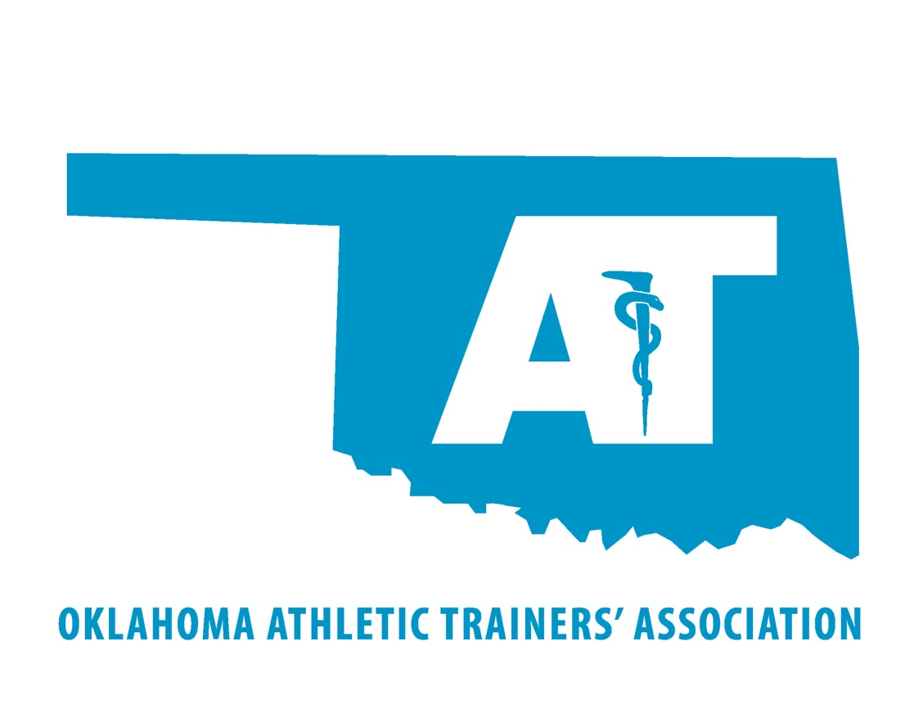

SPONSOR &
VENDOR PACKET

2024 Oklahoma Athletic Trainers’ Association
Annual Meeting & Clinical Symposium

2024 Annual Meeting and Clinical Symposium
May 31st & June 1st, 2024
On behalf of the Oklahoma Athletic Trainers’ Association, we would like to offer you and your organization an invitation to support the Oklahoma Athletic Trainers’ Association.
For the last several years, your organization employs or works closely with Licensed Athletic Trainers to oversee the needs of your patients, workforce, and/or educational institutions. As I am sure you have noticed, the athletic trainer consistently demonstrates a profitable return on investment that keeps your patients healthy and your healthcare costs down. Athletic Trainers are critical first responders in schools all across the state. Our state association helps to spread the word about what we do, and continues to fight for proper legislation in our state.
Every year, the Oklahoma Athletic Trainers’ Association works to serve the professional and educational needs of your athletic trainers. As a 501(c)(6) not-for-profit organization of more than 400 healthcare providers in Oklahoma, we provide a network of comradery, continuing medical education, and professional support to improve the quality of life and enhance the quality of service of all athletic trainers in the state.
This year’s Annual Meeting and Clinical Symposium is May 31st & June 1st, located at the Oklahoma State University Center for Health Sciences in Tulsa.
As a sponsor, it is our belief that an investment in the OATA is an investment in your own athletic training healthcare team.
Vendor booth space will also be available in the Exhibitor Area. Set up will be available at 11:00am on Friday, with tear down being by 9:00pm that evening.
This meeting will provide you the opportunity to show your product line to those who are directly involved in the health care of athletes and the physically active. These professionals work in a variety of settings, such as high schools, universities, clinics, industrial, and professional sports.
Thank you for your support to the Oklahoma Athletic Trainers’ Association and its membership throughout the year. We hope to see you at this year’s event.

Sponsorship & Vendor Packages

Platinum Sponsor Level: $3,000.00
- Banner Advertisement at Annual Meeting
- Recognition on OATA Website
- Symposium Recognition
- Free Symposium Registration for 3 Athletic Trainers
- 3 Complimentary Awards Banquet Tickets
- Job Posting on Communication to Members
- Year-Round Recognition on All Membership Publications
- Free Vendor Booth at the Annual Meeting
- Logo on the OATA T-shirt for Attending Athletic Trainers
Gold Sponsor Level: $2,000.00
- Banner Advertisement at Annual Meeting
- Recognition on OATA Website
- Free Symposium Registration for 2 Athletic Trainers
- 2 Complimentary Awards Banquet Tickets
- Job Posting on Communication to Members
- Year-Round Recognition on All Membership Publications
- Free Vendor Booth at the Annual Meeting
- Company Name Listed on the OATA T-shirt for Attending Athletic Trainers
Silver Sponsor Level: $1,000.00
- Banner Advertisement at Annual Meeting
- Recognition on OATA Website
- Free Symposium Registration for 1 Athletic Trainer
- 1 Complimentary Awards Banquet Ticket
- Year-Round Recognition on All Membership Publications
- Company Name Listed on the OATA T-shirt for Attending Athletic Trainers
Vendor Level: $200.00
- Vendor booth on Friday, May 31st
- 2 Tickets to the Hall of Fame Banquet on Friday night

We can also build a sponsorship package that fits your organization’s specific requests.
Please use this link to register as a sponsor &/or vendor.
To get a custom package or if you have questions about the form or payment, please contact Lindsay Moore at: oatameeting@gmail.com
Thank you once again for your consideration and for your support of the athletic training profession.
Respectfully,
Casey Paulk, President
Oklahoma Athletic Trainers’ Association
918-688-8599
president@oata.net

